



Module Code & Module Title
CC4057NP Introduction to Information Systems

Assessment Weightage & Type
30% Individual Coursework

Year and Semester
2021-22 Autumn

Student Name:
Group:
London Met ID:
College ID:
Assignment Due Date:
Assignment Submission Date:

I confirm that I understand my coursework needs to be submitted online via Google Classroom under the relevant module page before the deadline for my assignment to be accepted and marked. I am fully aware that late submissions will be treated as non-submission and marks of zero will be awarded.

Table of Contents
1. Introduction of a database 1
1.1 Introduction of the selected Organization 1
2. Data Modelling 4
2.1 Creating tables, inserting values and description of table 4
2.2 Entity Relation Diagram 13
3. Data Dictionary 16
4. Queries 20
Bibliography 30

List of Figures

Figure 1- creating table customers 4
Figure 2-inserting value in customers 5
Figure 3-Describe customers table before inserting value 5
Figure 4-Describe customers after inserting value in it 6
Figure 5-creating halls table 6
Figure 6-inserting value in halls 7
Figure 7-describe hall table before inserting value 8
Figure 8-description halls after inserting value in it 8
Figure 9-creating table locker 8
Figure 10-inserting value in the locker 8
Figure 11-description before inserting value in it 9
Figure 12-description after inserting value in it 9
Figure 13-creating table employees 9
Figure 14-Inserting value iemployee’sloyees table 10
Figure 15- description before inserting value in the employee table 10
Figure 16-description after inserting value in the employee table 11
Figure 17-creating table tickets 11
Figure 18-inserting value in the ticket table 12
Figure 19-description before inserting values in tickets 12
Figure 20-description after inserting values in tickets table 13
Figure 21- Entity Relation Diagram 14
Figure 22-Class Diagram 15
Figure 23-Using LIKE operator in table 20
Figure 24-Using DISTINCT in table 21
Figure 25-Using BETWEEN in table 22
Figure 26-Using IN in table 23
Figure 27-Using Order By in table 24
Figure 28-Using UPDATE in table 25
Figure 29-Using GROUP BY in table 26
Figure 30-Using MAX in table 27
Figure 31-Using JOIN in table 27
Figure 32-Using LIMIT in table 28

List of Tables

Table 1 data dictionary of Locker. 13
Table 2 data dictionary of Employee 14
Table 3 data dictionary of the hall. 14
Table 4 data dictionary of the ticket. 15
Table 5 data dictionary of Customer. 16

Introduction of a database

Introduction of the selected Organization

The organization I have chosen for designing the database is Skate Park which is located in Buddhachowk 10, Pokhara. The name of this organization is Inline Skate which was established on May 20, 2021, by Santosh Gurung. Inline skates are a type of roller skate used for inline skating on the other hand it is a versatile sport and can refer to practised activities. The inline skate park is about 150meters down from Buddha chowk on the way to Ram Bazaar. Here we can enjoy and learn skating at an affordable price. It can be a great facility for those who are not much active in their day-to-day life it can also help in adolescent development. It can be a catalyst for healthy community life in which young and old socialize, have fun, develop new skills, make new friends, hang out, and much more.


Figure 1-Picture of Skate park

There are only two such parks in Pokhara. (1) Skate park is located at Buddha Chowk and another is in lakeside Khahare Chowk. Skate is ultra low impact, which means it puts less stress on the joints of our body. It is helpful for our body to build up our leg muscles, hips, and so on. There are a lot of people in the skate park zone, some for fun, some for sightseeing, and some come for visit only. Some people come for sports and their body fitness. For this kind of organization, a management system is a must. If the data is not managed properly then an organization may face a lot of problems related to its data such as losing the information of the customer, staff members, and so on. Due to improper management of the database, it can be slower when we try to retrieve some data from an organization. When the data is arranged suitably, we can instantly decide if an organization tries to change something in less time for the customers to attract them.

In this organization it feels like the data that is related to this organization is not stored properly. So in such a case, it is a little bit difficult to know about them deeply if a person wants to know it. So a new database design is required to manage them properly. Here data is a collection of undefined figures and facts. After the collection of the data only we can get a piece of meaningful information that allows the decision-maker to take the action for the organization. The database of the selected organization keeps a record of customers, locker, addresses, dates, durations, records, and tickets. Different sorts of problems occur when a staff wants to know about their data redundancy and to retrieve them when they are needed. So to overcome such types of problems we need a proper database. The database is really helpful for such an organisation that helps save storage space and automatically generates the backup data and restore it if required. The database helps to manage the organization and also can bring change within less time if the information is managed in a proper way to do so every organization should design a database before starting it.

When the data is entered in an organization it supports the quality of information which helps to describe the provided information about the database. Simply the database is a collection of operations that provides a user with a comfortable zone to perform updating, deletion, and insertion of the customer’s details. The database has many advantages as compared to any other form of record-keeping system. As we all know that it is the most efficient way of storing and sorting data. In this organization creating a database or designing it helps to manage the improper system in a systematic and easily assessable.

Objects of creating this database of selected organizations are listed below:
- It allows you to enter, store, analyze and compile the data however you want.
- Accessing the data related to any problems can be managed properly in less time.
- Data redundancy can be removed easily for the better future progress of the organization.
- Whenever the data is needed we can check them directly by visiting the handling department of the organization which may consume less time and many tasks can be done at the same time while staffs are busy with the customers.
- Multiple customers can be accessed.
- Platform independent.
- Integrity
- Mass Storage of the data for collecting the information.

Data Modelling
Data modelling is the process of creating a well-defined diagram of an entire system of an organization and it is the visuals representation data items and their relationships.

Creating tables, inserting values and description of the table
Here different tables are created to describe the entity chosen for creating for designing the database. The attributes are also included in it by using the datatype necessary to use.

Creating the database and using it:
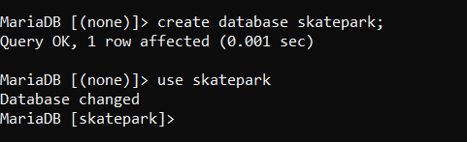
Figure 2-Creating database

- Customer
Here the customer is an entity of an organization creating customer tables to store data in it.
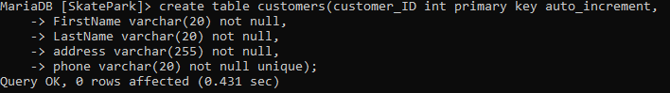
Figure 3- creating table customers

Inserting value in customer table:
Before retrieving values from the customer table we need to insert the value in the customer table.
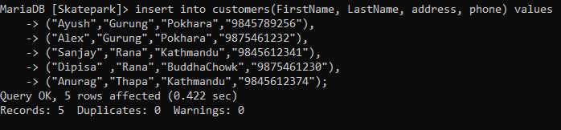
Figure 4-inserting value in customers

Description before inserting value:
Here we can see the description of the customer before inserting the values in the table.
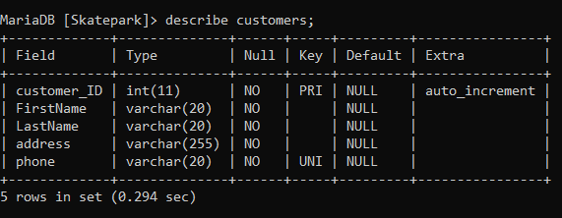
Figure 5-Describe customers table before inserting value

Showing value of customers table after inserting a value into it:
With the help of the given table, it has shown the information after inserting values in the customer’s table.
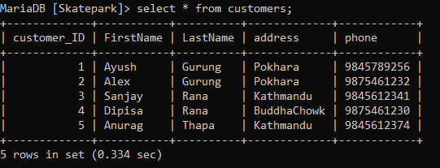
Figure 6-Describe customers after inserting value in it

- Hall
This is used to create the table of halls to keep the records of the halls for the collection of data information.
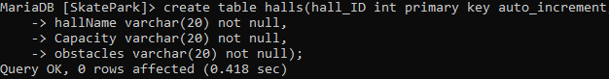
Figure 7-creating halls tables

Inserting value in Hall table:
We can see that this is run to insert the values in the halls table.
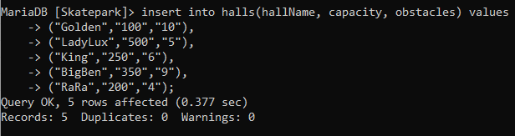
Figure 8-inserting value in halls

Description before inserting values in halls:
This figure shows the description of halls before insertion in the table.

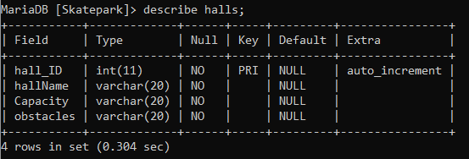
Figure 9-describe hall table before inserting value

Description after inserting values in halls table:

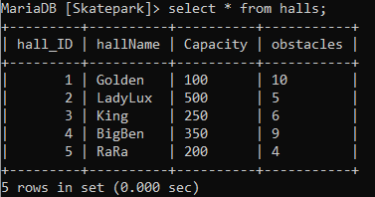
Figure 10-description halls after inserting value in it

- Locker
Figure 11-creating table locker

Inserting value in Lockers:

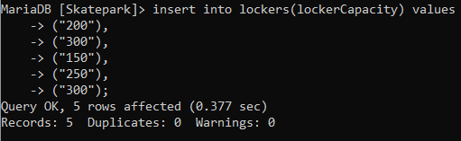
Figure 12-inserting value in the locker

Description of locker table before inserting a value into it:

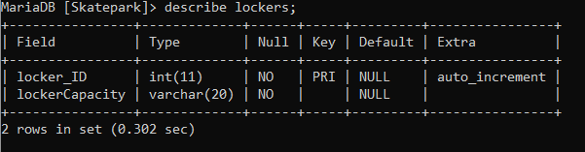
Figure 13-description before inserting value in it

Description of the locker after inserting a value into it:

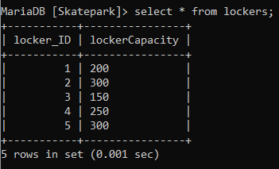
Figure 14-description after inserting value in it

- Employees
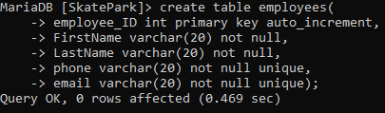
Figure 15-creating table employees

Inserting value in employees table:

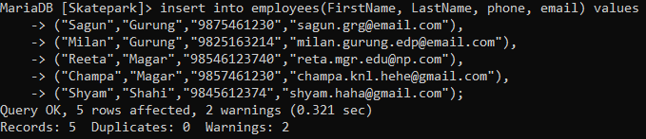
Figure 16-Inserting value iemployee’sloyees table

Description before inserting value in employee table:

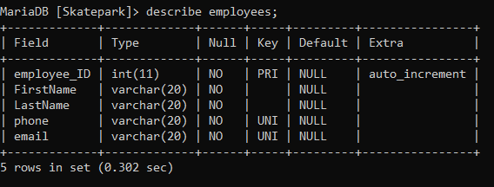
Figure 17- description before inserting value in the employee table

Description of employee table after inserting value in it:

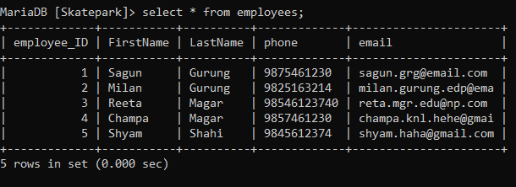
Figure 18-description after inserting value in the employee table

- Tickets
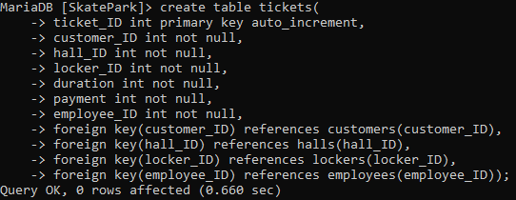
Figure 19-creating table tickets

Inserting values in Ticket table:

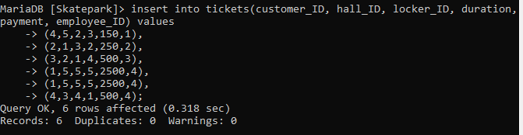
Figure 20-inserting value in the ticket table

Description before inserting values:

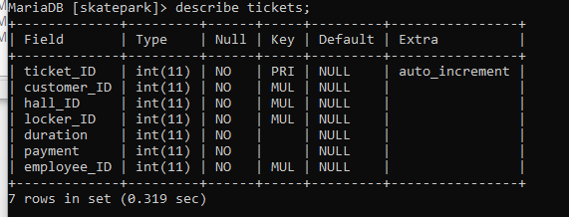
Figure 21-description before inserting values in tickets

Description after inserting values into it:

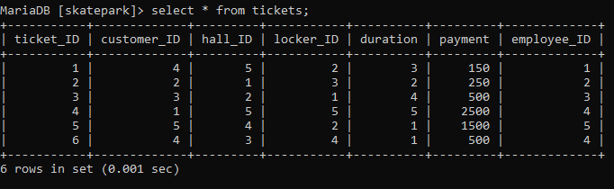
Figure 22-description after inserting values in tickets table

Entity Relation Diagram

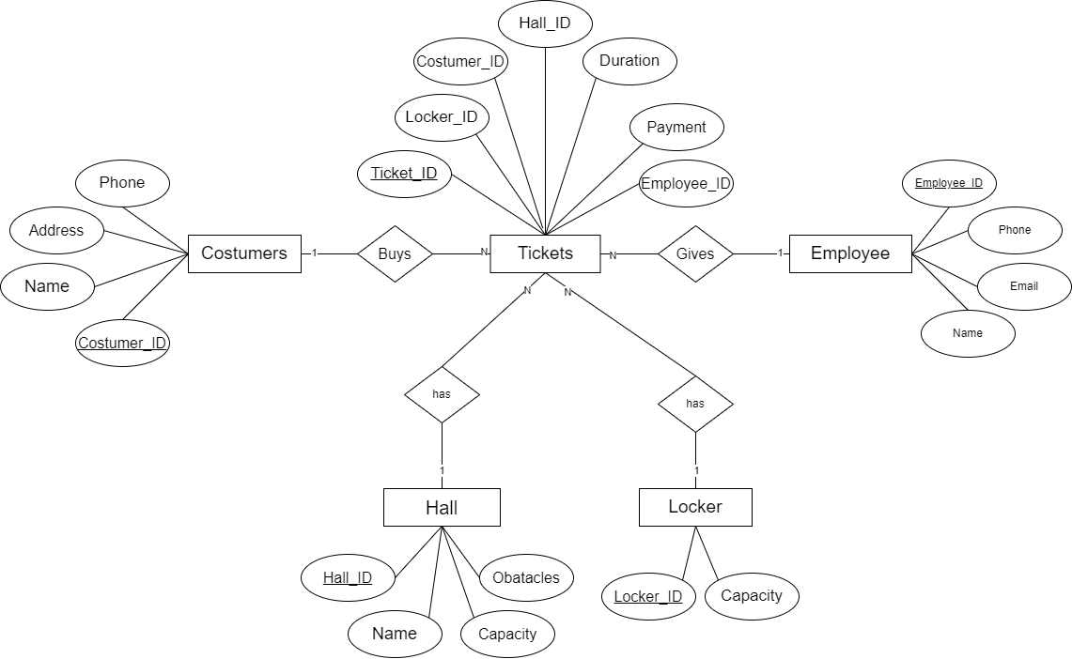

Figure 23- Entity Relation Diagram

  - Relation Diagram of the selected Organization.

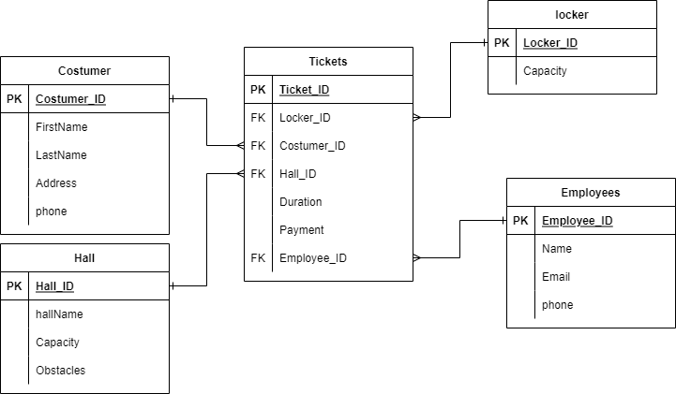
Figure 24-Class Diagram

Data Dictionary

- Data Dictionary of Locker

Table 1 data dictionary of Locker.
Entity Name | Entity Description | Column Name | Column Description | Data Type | Length | Primary Key | Foreign Key | Nullable | Unique | Notes
Locker | A locker is a small cabinet to store customers’ personal belongings. | locker_ID | Uniquely identifying the number of a locker. | INT | 11 | True | False | False | True | Auto incremented
Locker |  | Capacity | The capacity of the locker. | Varchar | 20 | False | True | False | False | References to capacity from the records table of the hall.

- Data Dictionary of Employee
Table 2 data dictionary of Employee
Entity Name | Entity Description | Column Name | Column Description | Data Type | Length | Primary Key | Foreign Key | Nullable | Unique | Notes
Employee | A person who looks after the hall and customers. | Employee_ID | Uniquely identifying the number of the employee. | INT | 11 | True | False | False | True | Auto incremented
Employee | A person who looks after the hall and customers. | Name | Name of the employee. | Varchar | 20 | False | False | False | False
Employee | A person who looks after the hall and customers. | Phone | The contact number of the employee | Varchar | 20 | False | False | False | True

- Data Dictionary of the Hall
Table 3 data dictionary of the hall.
Entity  Name | Entity  Description | Column  Name | Column  Description | Data  Type | Length | Primary  Key | Foreign  Key | Nullable | Unique | Notes
Hall | Hall is a confined space built specifically for skaters to skate. | HalI_ID | Uniquely identifying the number of a hall. | INT | 11 | True | False | False | True | Auto  incremented
Hall |  | Name | Name of the hall. | Varchar | 20 | False | False | False | False
Hall |  | Capacity | The capacity of the hall. | Varchar | 20 | False | False | False | False
Hall |  | Obstacles | A number of the obstacles inside the hall. | INT | 20 | False | False | False | False

- Data Dictionary of Ticket
Table 4 data dictionary of the ticket.
Entity  Name | Entity  Description | Column  Name | Column  Description | Data  Type | length | Primary  Key | Foreign  Key | Nullable | Unique | Notes
Ticket | Ticket is given data to the customer on what to get and what not to get. | Ticket_ID | The uniquely identifying number is given to the customer. | INT | 11 | True | False | False | True | Auto incremented
Ticket |  | Customer_ID | Uniquely identifying the number of the customer. | INT | 11 | False | True | False | False | References to Customer ID from the customer table.
Ticket |  | Hall_ID | Uniquely identifying the number of the hall. | INT | 11 | False | True | False | False | References to hall id from the hall table.
Ticket |  | Locker_ID | Uniquely identifying the number of the locker. | INT | 11 | False | True | False | False | References to locker id from the record of locker table.
Ticket |  | Duration | Defined time duration of the customer. | Varchar | 20 | False | False | False | False
Ticket |  | Payment | Payment is done by the customer. | Varchar | 20 | False | False | False | False
Ticket |  | Employee_Id | Uniquely identifying the number of the employee. | INT | 11 | False | False | False | False | References to employee _id from the employee table.

- Data Dictionary of Customer
Table 5 data dictionary of Customer.
Entity  Name | Entity  Description | Column  Name | Column  Description | Data  type | Length | Primary  key | Foreign  key | Nullable | Unique | Notes
Customer | A customer is a person who takes skate shoes for rent per hour. | Customer_ID | Uniquely identifying the number of a customer | INT | 11 | True | False | False | True | Auto incremented
Customer |  | Name | Name of the customer | Varchar | 20 | False | False | False | False
Customer |  | Address | Address of the customer | Varchar | 20 | False | False | False | False
Customer |  | Phone | Phone number of the customer | Varchar | 20 | False | False | False | True

Queries

A query is a statement that is used to retrieve the data from the database in a SQL that helps in data deletion, addition, insertion, and selection too.
MySQL has many built-in functions. Which contains a string, numeric, date, and some advanced functions in MySQL. In this database, we used INSERT and DESCRIBE to run the SQL database.

INSERT:
Insert is a String within a string at a specific position and for a certain number of characters.

- LIKE Operator

Here like operator is used in a WHERE clause to search for a specified pattern in a column. From the below figure I have taken out the names whose names start from (a) which we can analyze by seeing the figure given below. In the like operator, two wildcards are used such as (%) and (_) etc.

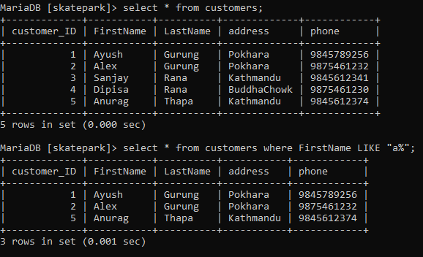

Figure 25-Using LIKE operator in a table

- DISTINCT Operator

The distinct operator is a statement that is used to return only the different values which often contains many duplicate values in the table but it shows only one value as a whole duplicate value. Here I have shown the address of a repeated value in a skate organization.

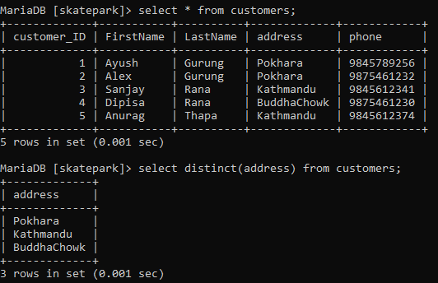
Figure 26-Using DISTINCT in table

- BETWEEN operator

Between operators is used to select values within a given range whose values can be numbers, text, or dates. In this organization, I have selected the halls to retrieve the data of capacity between 100 and 300 whose value is given below.
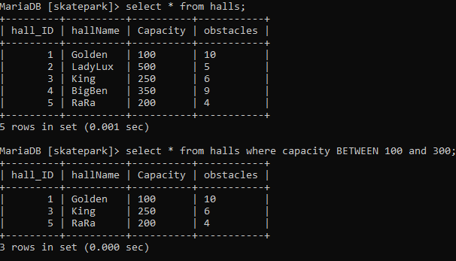
Figure 27-Using BETWEEN in table

- IN Operator

The IN operator allows the user to specify multiple values in records also here the records are shown in the figure below.
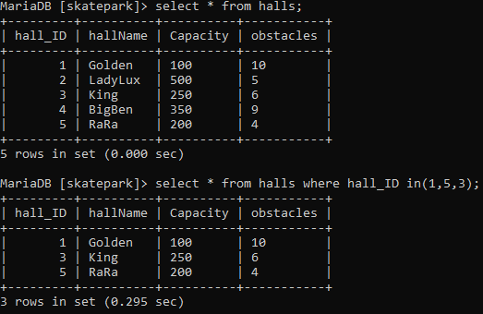
Figure 28-Using IN in table

- ORDER BY operator

Order by is used to list the records or data in an ascending or descending order for this we use keyword desc for descending value and asc for ascending value in my SQL. In the below figure we can see the data in descending order which is possible only using order by in my SQL.

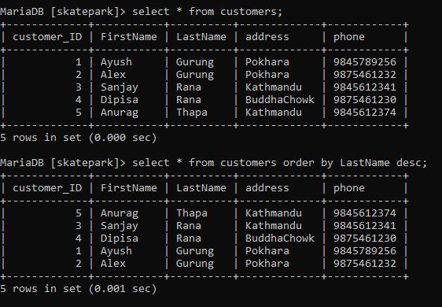
Figure 29-Using Order By in table

- UPDATE statement query

The update statement is used to modify the existing records in the table.
Here again in the given figure I have updated the name of one record and shown the updated records together.

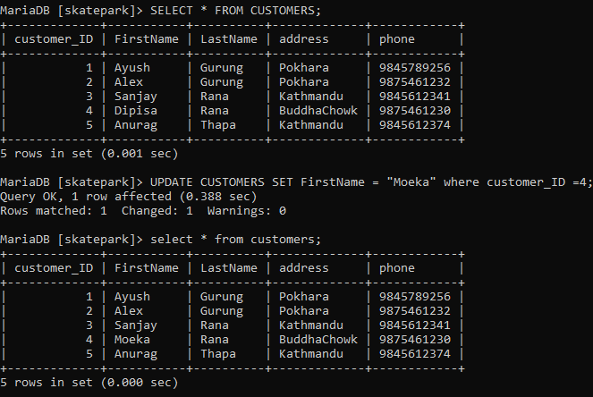
Figure 30-Using UPDATE in table

- Group By Statement Query

Here the count is used to show the number of rows that matches a specified value and the GROUP BY statements group’s rows that have the same values into the summary rows. Also, this statement is often used with aggregate functions in my SQL.
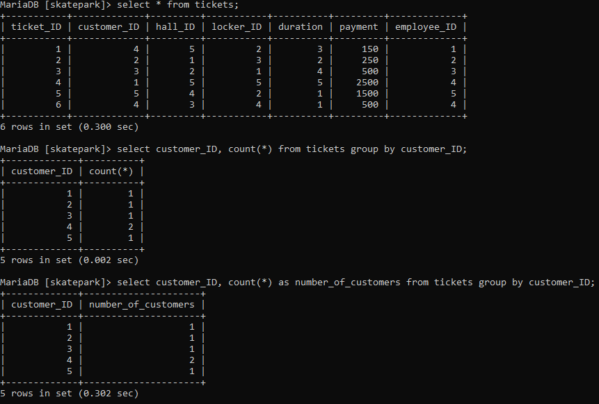

Figure 31-Using GROUP BY in the table

- Max()
The MAX function returns the largest value of the selected column of an inserted record as in the given figure I have taken out the max value from the tickets table from the selected organization.

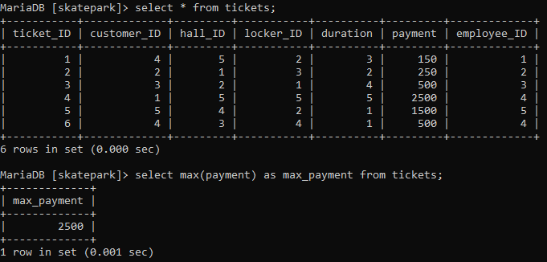
Figure 32-Using MAX in table

- JOIN statement

Join clause is used to combine rows from two or more than two tables, based on a related column between them. And here I have joined the hall and ticket and customer to show the first name of the customer and name of the hall which is possible only if that have matching values in both tables.
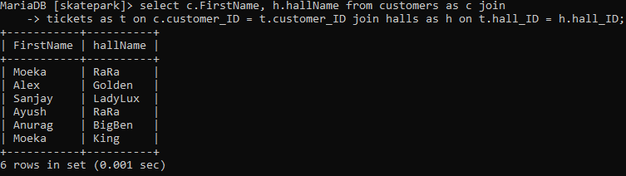
Figure 33-Using JOIN in table

- LIMIT Statement Query
As we know that the LIMIT clause is used to specify the number of records to return which is very helpful on large tables with lots of records. Also here I have shown the records of the highest capacity of the hall.
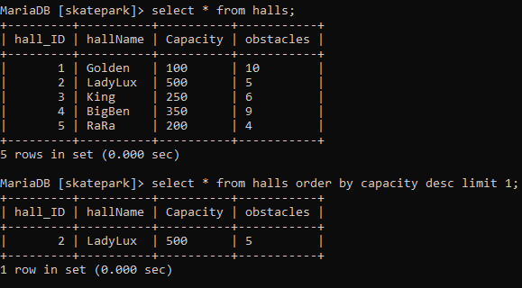
Figure 34-Using LIMIT in table

Creating a dump file of an organization

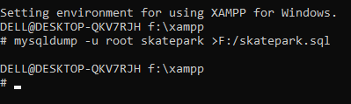
Figure 35-Creating dump file

Conclusion

Bibliography

